E-Bike setup:

Electrical Setup:

**Battery:**

**HAILONG-PLUS 36V 19.2AH (Supplied with 3A Charger)**  
**Specification:**

Rated capacity: 19.2AH  
4P10S Li-ion 4.8Ah 21700 40pcs battery cells (the interior battery is SAMSUNG INR21700-48X 21700 Li-ion battery)

**The motor:**

This Tongsheng mid drive motor with torque sensor The TSDZ2 is “torque-sensing” (Torque sensors measure if and how hard you are pedalling)– if you pedal gently, you get a gentle assist; if you pedal hard, the motor works harder.

This differs from the other common mid-drive kit (Bafang) which is cadence sensing (Cadence sensors measure if you are pedalling)– you set the assistance you want, and so long as the pedals are turning, the motor gives that flat level of assist.

TSDZ2B electric bicycle central mid motor with torque sensor  
Speed: 15Km/H-45Km/H    top speed 45km/H

You have four levels of assistance ECO, TOUR, SPEED and TURBO. Each one providing more assistance than the last but obviously also consuming more battery as well. This assistance is supplied when the built-in pedal torque sensor determines it’s required.

# Also Equipped with:

# VLCD5 LCD Display & LCD controller.

The display give full functionality and is well laid out for this kit. It can be controlled via buttons on the display unit itself and also has a remote / LCD controller which is mounted nearer the hand-grips for easier Control.

**Controller Setup – Brake / Throttle setup**

**Thumb Throttle:**

Another way to get an extra boost, which is to use the Thumb Throttle. When Applied / Activated it will override the pedal sensor and supply the additional Power as you require. It’s a proportional control, so you control how much power you add. (Continued use = Extra Battery Use) The further you press the lever, the more power the motor delivers and the faster you’ll go. To reduce the power, you pull your thumb back. To cut the power, you release your thumb from the throttle and the lever springs back– Very handy for Quick take off or extra assistance when required.

With a throttle, you don’t have to peddle the bike at all to move if you don’t want to. The motor does all of the work

Just to Note – Throttles are Requested if required and Fitted by customer.

It’s important to note that throttle controlled ebikes are not legal in some cities and countries. This is the case in much of Europe. In some countries, ebikes that have a throttle are not classified as bikes. Instead, they are considered mopeds and are regulated differently.

**Safety Motor Cutoff Brake levers:**

The braking system is one of the critical parts on your ebike.

The main point that makes an electric bike differ from a standard bicycle is the motor cutoff switch, a safety feature, and even a law required in the US.

The motor cutoff switch, or brake cutoff switch, is a mechanical or magnetic switch Within the braking system connected to the lever. When the lever is pulled a signal is sent to the Motor Controller, to tell the controller to disable the motor. This means you cannot use the motor and the brake at the same time for safety reasons.

if you’re not using the throttle, replacing your existing brake levers isn’t strictly necessary because of the way the pedal sensors work, but I personally would always rather be safe than sorry.

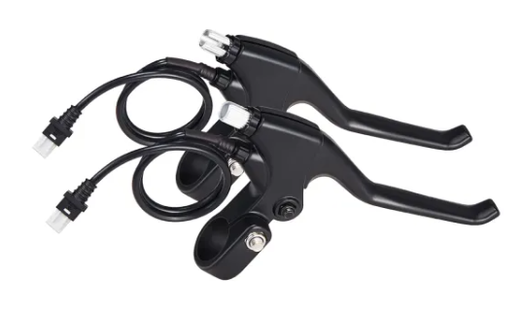

# Speed Sensor with Y Splitter for Headlight and Taillight Connections For 6V 3W Lamp.

Also Added to the setup are the Front and Rear tail Light – controlled at LCD controller:

